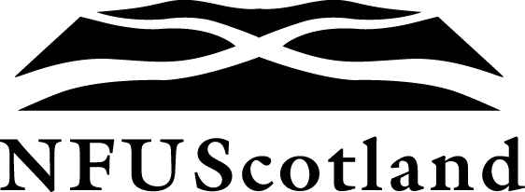
News Release
Date : 14 June 2023
Number : 38/23
Contact : Bob Carruth
Telephone : 07788 927675
Email : bob.carruth@nfus.org.uk
SCOTTISH GOVERNMENT AND HEALTH AND SAFETY EXECUTIVE MUST RECOGNISE ASSURANCE IN PESTICIDE ENFORCEMENT
Joint statement on behalf of NFU Scotland, Scottish Quality Crops, Quality Meat Scotland and Agricultural Industries Confederation calls for unnecessary bureaucratic burden to be avoided.
Scottish farming organisations are calling for Scottish Government and the Health and Safety Executive (HSE) to recognise that farm and trade assurance membership demonstrates that businesses are complying with their duties under Plant Protection Product (PPP) law.
A post-Brexit regulatory requirement has seen the HSE announce that Pesticide Enforcement Officer (PEO) inspections of businesses and users of professional pesticides is due to commence in October 2023 under the Official Controls Regulation (OCR).
In a joint statement, NFU Scotland, Scottish Quality Crops (SQC), Agricultural Industries Confederation (AIC) and Quality Meat Scotland (QMS) are calling for businesses and users of professional pesticides who have their businesses audited as part of a trade or farm quality assurance scheme to have ‘earned recognition’ and to be ex. t from a duplicate audit under this government scheme.
The organisations state: “We want Scottish Government and the Health and Safety Executive (HSE) to recognise that a successful farm and trade assurance audit already demonstrates that businesses are complying with their duties under Plant Protection Product (PPP) law. Farm and business audits are conducted annually as part of independent farm and trade assurance inspections. In Scotland, the relevant farm assurance bodies are SQC and QMS.
More/…
2/…
“Farm businesses and businesses who are audited annually and prove that they are compliant by achieving assured status, should have ‘earned recognition’ that they are complying with their duties under PPP law. Duplication of audit is an unnecessary bureaucratic burden for all businesses and the HSE.
“In a commitment to remove red tape and improve simplification, we ask that HSE recognise farm and trade assurance standards as an appropriate and robust mechanism to inspect and assure businesses. It is an existing mechanism that gives businesses the earned recognition that regulations are being complied with.
“We call on Scottish Government and HSE to recognise that the requirements of farm and trade assurance standards demonstrate compliance with businesses’ duties under PPP law.” Ends

