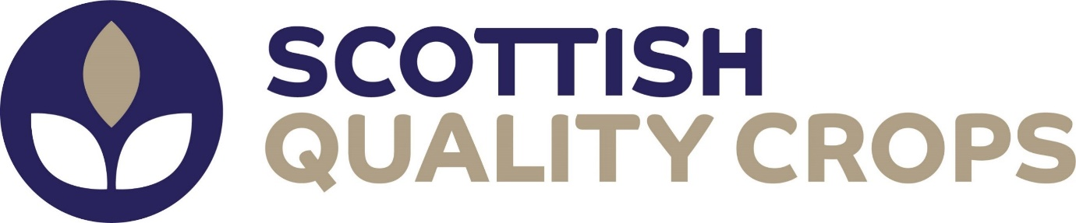

2021 Report

Annex 1: list of information to be reported by the voluntary schemes

Scottish Quality Crops (Ltd)

- the independence, modality and frequency of audits, both in relation to what is stated on those aspects in the scheme documentation, at the time the scheme concerned was approved by the Commission, and in relation to industry best practice:

These are all unchanged. All farms are assessed on an annual basis.

- the availability of, and experience and transparency in the application of, methods for identifying and dealing with non-compliance, with particular regard to dealing with situations or allegations of serious wrongdoing on the part of members of the scheme:

Assessors carry out assessments in a formatted order to ensure consistency of audit and all members of the scheme are provided a copy of the current SQC Manual which details the procedures for identifying and classifying non-conformances and dealing with allegations of wrongdoing on the part of members

- transparency, particularly in relation to the accessibility of the scheme, the availability of translations in the applicable languages of the countries and regions from which raw materials originate, the accessibility of a list of certified operators and relevant certificates, and the accessibility of auditor reports:

Access to the Scheme Manual and supporting documentation is clearly shown on the SQC website (https://www.sqcrops.co.uk). Accessibility to details of certified operators and relevant certificates is still via the log in on the SQC website. The database tracker and membership checker are the definitive means of confirming assurance at any given date. The on-line checker also identifies compliance status for biofuel or bioliquid markets. SQC only operates in the United Kingdom in English and there is no requirement for translation. SQC operates a single Certification Body policy.

Audit reports are confidential and held by the CB. A non-conformance report is supplied to the grower(s) after the assessment and certificates are then emailed to growers following correction of any non-compliances. SQC requires the CB to furnish them with full details of audit reports on request.

- stakeholder involvement, particularly as regards the consultation of indigenous and local communities prior to decision making during the drafting and reviewing of the scheme as well as during audits and the response to their contributions:

SQC is a not for profit Company. Scottish Quality Crops Ltd (SQC) is a cooperative and the members of the cooperative are: National Farmers Unions of Scotland, Agricultural Industries Confederation, Scottish Flour Millers Association, Scottish Agricultural Organisation Society, Maltsters Association of Great Britain, The Scottish Whisky Association and SRUC. The Board members have a wide range of experience and represent interests from all areas in which SQC operates. Specialist technical industry advice is accessed when required via the Technical Group.

The Standards are under continuous review. The last full review was undertaken in 2021 and a further review in relation to compliance with the recast RED/Directive (EU) 2018/2001 is being undertaken in 2022.

- the overall robustness of the scheme, particularly in light of rules on the accreditation, qualification and independence of auditors and relevant scheme bodies:

The rules of the Certification Body, LRQA, are published on the SQC website. The certification body is accredited to ISO17065 by UKAS and has the relevant extension to scope to certify the SQC Scheme standards. Full details of the normative and supporting documentation has been provided to the EU Commission as part of the application for recognition as a VS under the recast RED (EU) 2018/2001. These documents cover accreditation, qualification and independence of auditors and relevant scheme bodies in addition to complaints procedures etc.

- market updates of the scheme, the amount of feedstocks and biofuels certified, by country of origin and type, the number of participants:

Annual reports will be submitted by SQC prior to 30 April each year and the reporting period will cover the previous harvest year as previously agreed with the EU Commission ( Bernd Kuepker, Policy Officer, Directorate General for Energy in January 2017. Relevant harvest dates for this submission are 1st October 2020 to the 30th September 2021. In addition, it is confirmed that the data will be submitted to the Commission in the format specified i.e. the Data Reporting template. SQC reports upon the following in terms of market update:
- country of origin and type of the feedstock (such as wheat, rapeseed etc.) certified in the relevant/specified harvest year ie for the current Annual Report 2020/21
- the number of scheme participants in that harvest year which for 2020/21 was 3158
- the amount of feedstocks certified as being compliant under RED taking account the total area of eligible crops verified at annual audit and the relevant final yield data for that harvest year for the crops as published by the Scottish and English authorities.

- the ease and effectiveness of implementing a system that tracks the proofs of conformity with the sustainability criteria that the scheme gives to its member(s), such a system intended to serve as a means of preventing fraudulent activity with a view, in particular, to the detection, treatment and follow-up of suspected fraud and other irregularities and where appropriate, number of cases of fraud or irregularities detected:

SQC only audits that land is compliant, or not, on an ongoing annual audit. This is recorded on a database. In addition a post harvest declaration form or grain passport (copy attached, 2021 version) accompanies each load leaving the farm and it includes a signed, dated declaration that the crop has been grown on land that meets the required sustainability criteria.

Any false or misleading statement made on the application form, during assessments or in any communication may lead to suspension or withdrawal of certification. Members are also required to notify the CB of any prosecution brought or likely to be brought against them with respect to any issues covered by the standards. Upon receipt of any enforcement challenges or prosecutions etc SQC is able to follow up with a thorough investigation.

- options for entities to be authorised to recognise and monitor certification bodies:

The Certification Body, LRQA, is accredited to ISO17065 by UKAS. SQC is an open and transparent organization and welcomes visits from interested bodies or persons. The SQC Certification Body protocol specifies that both SQC and the CB will allow relevant authorities in Member States and the EU Commission to supervise the operation of certification and to ensure relevant data is made available.

- criteria for the recognition or accreditation of certification bodies:

As in point (h) above and detailed in the SQC Certification Body Protocol

- rules on how the monitoring of the certification bodies is to be conducted:

SQC requires that there is an annual audit of the certification body by UKAS and other monitoring requirements are specified in the SQC Certification Body Protocol

- possibilities to facilitate or improve promotion of best practice:

The Board of SQC strive to promote best practice and good governance and this policy is continually reviewed. There is ongoing liaison with research institutions, industry, farming organisations and government departments which delivers co-operation and ensures that the SQC standards reflect current best practice whilst remaining practicable and relevant.

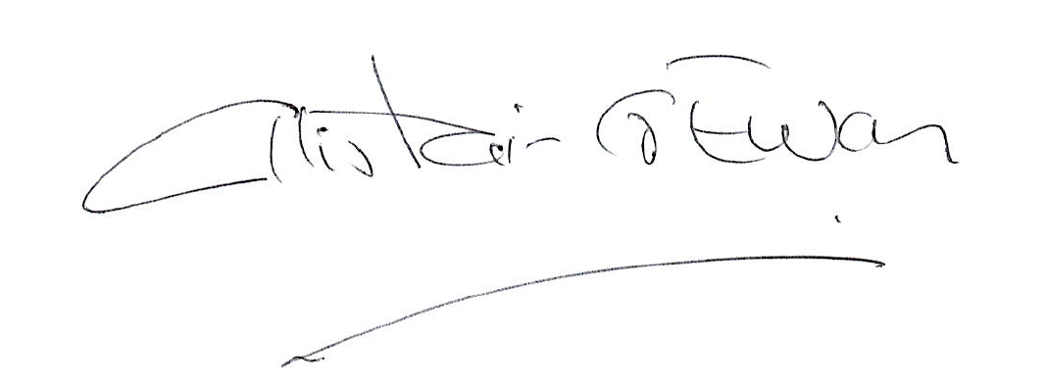

Alistair Ewan
Executive Director & Company Secretary

